**Top Java script interview questions**

**00:21 - Can a JavaScript object hold a function as a property? Explain with an example.**

Yes its hold a function with property also. see the code

Greet is the property that’s call a **anonymous function.**

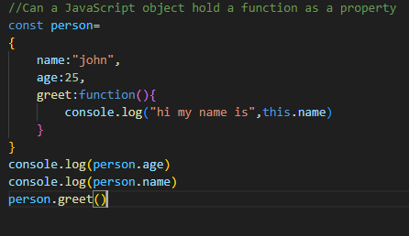

o/p

**03:28 - What are anonymous functions in JavaScript? Define their syntax and implementation.**

A function without any name representation is known as **anonymous function.**

If the function have name so need to collect in any variable but if we have the name of the function then we need to collect in a variable and by this variable we can call the function.

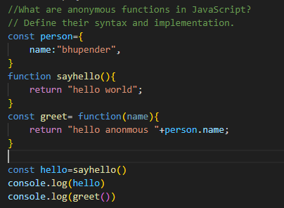

o/p

**07:22 - What is the difference between var, const, and let? Explain with an example.**

Var:- is the default variable type in java script if there is no variable type then var is default taken

Var: - is the variable type which is function scoped or global scoped. It means if we declare the value as var in blocked or one in global then in last what is the value previous declared its takes that value only.

Let :- is the blocked scope , its work only in block. Means one let variable in global and one is in block so this value is sustain in block and in global , when we call the let variable from outside block then its point to global.

Const:- is blocked scope can not be updated or re declared. If we declare the same variable two times with const then its thrown an error.

Code is:-

// var is a function=scoped and global scope and can be re declared and updated

o/p

**16:26 - Where are the push, pop, slice, shift, and unshift methods used when accessing array elements?**

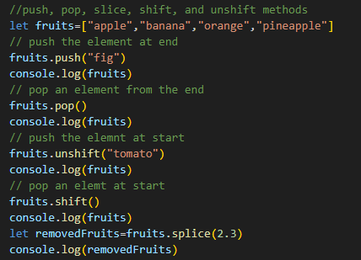

**o/p**

**23:19 - Is JavaScript Asynchronous? Prove with an example.**

**Synchronous means maintain an order of execution.**

**Asynchronous means not maintain an order for the execution.**

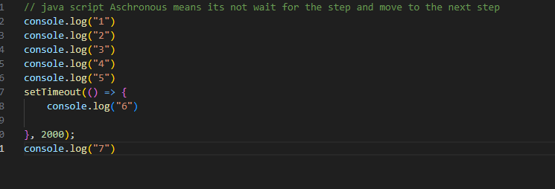**o/p**

**27:53 - What are callback functions in JavaScript?**

A callback function is a function that passed an argument to an another function and is executed after some of the operation is executed. Callbacks are often used for asynchronous operation.

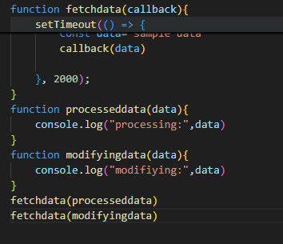

o/p

**38:09 - What are promises in JavaScript? Explain the difference between callback functions and promises with an example.**

Promises makes the statement to be executed.

Callback function is the function call based on another function argument.

Promise function:- is call based on statement makes and call it for resolve, pending and rejected

In the code fetechdata() is the promise and check its resolved or not.

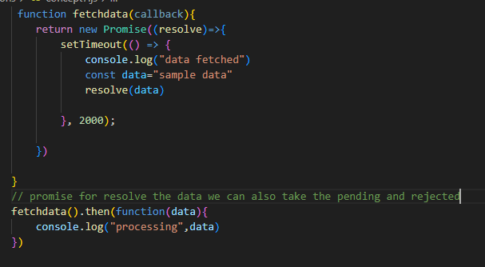

**o/p**

**49:15 - Create an inheritance relationship between a parent and child class. Invoke the parent constructor from the child class. Create main.js to call parent class methods from a child class object.**

This concept has been described by three classes.

Class 1:- person

**Class 2 :- student**

**Class 3:- main**

**55:21 - From the above code, explain how the super and these keywords help achieve the solution.**

Super is the keyword which is help to call parent class constructor.

**01:00:05 - What is the difference between == and ===?**

== is to be compare the content only

=== is to be compare the content as well as type also.

**o/p**

**01:03:32 - What is the difference between null and undefined in JavaScript?**

Null is the value which is defined for the variable

Undefined:- is the value which is not defined for the variable.

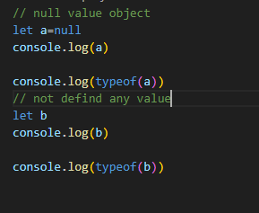

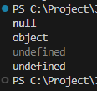

**01:06:36 - A classic programming interview question that involves using array methods (filter, map, reduce), and JavaScript objects.**

**Create an array of objects representing students with their names , scores and get the below result with optimized solution.**

1. **Filters out students who passed in the exam with score more than 36**
2. **Update passed students names to uppercase**
3. **Total score of all passing students**

**Solution**

**o/p**

